Course Project – Change Request Documentation

Shaun Pritchard

Rasmussen College

CDA3315C

Alan Dennis

August 6, 2020

**Clickable Index:**

***Ctrl + Click*** *on the index section number below to avoid having to scroll and instantly jump to the newest updated section. I will add a new link each week*

1. Project Documentation
2. Analysis Documentation
3. Design Documentation
4. Implementation Documentation
5. Maintenance Documentation
   1. Baseline Metrics Chart
6. Change Request Documentations

|  |  |  |  |
| --- | --- | --- | --- |
| Enterprise Architecture Use-Case Change History – Rasmussen Web Application | | | |
| Name | Change description | Date of Change | Version |
| Shaun Pritchard | Added design Documentation | July 23, 2020 | 1.0.3 |
| Shaun Pritchard | Added Implementation documentation | July 30, 2020 | 1.0.4 |
| Shaun Pritchard | Added Maintenance documentation | August 6, 2020 | 1.0.5 |
| Shaun Pritchard | Added change Request documentation | August 10, 2020 | 1.0.6 |

# Project Documentation:

**Use case:** Project Use-Case-1.0.0

**Created by:** S.P

**Date Created:** 07-10-2020

**Actors:** Lead, Users, Subject Matter Experts (SME)

**Priority:** 1

**Project Summary:**

This project will facilitate a cloud web-based inventory system that will inventory database structures with output responses based on user input. I would like to abstract the database modeling to output the design structure for input queries based on the relationships of the modeling and layered database architecture for enterprise systems. This will be implemented throughout the project schedule.(See Project Schedule)

**Project Schedule:**

6 weeks is proposed based on the following schedule to complete the proposed enterprise architecture system implementation.

|  |  |  |
| --- | --- | --- |
|  | **Project Schedule** | |
| **Description** | **Action** |
| **Week 1** | Use-Case | Create New use-case and define application purpose. |
| **Week2** | Modeling baseline & Database | Define software & system requirements. Model database |
| **Week3** | Web & interface development | Create web components and interfaces to communicate with backend |
| **Week4** | Testing | Document the user acceptance testing environment |
| **Week 5** | Deployment | Document the definition of scope creep create maintenance documentation |
| **Week 6** | Security & reporting | Enhance the project documentation |

**Project Components**

Will explain and consider the risks and analysis for software requirements, hardware requirements, staffing, timelines, and project costs of the cloud-web based inventory system.

**Risk**

Time could be a factor that would threaten the projects success variants of details and complexity could be cause. Also, unseen changes and constraints could pose factors that would hinder the timeline in question for the project’s completion. This complexity and constraints could come from database modeling and building interfaces to the front-end web application.

**Analysis**

Overall, there is not enough data to propose a full analysis of the overall project. Based on system constraints and abstraction the web application seems to be a fairly easy task with minimum milestones which can be easily implemented.

**Use case diagram:**

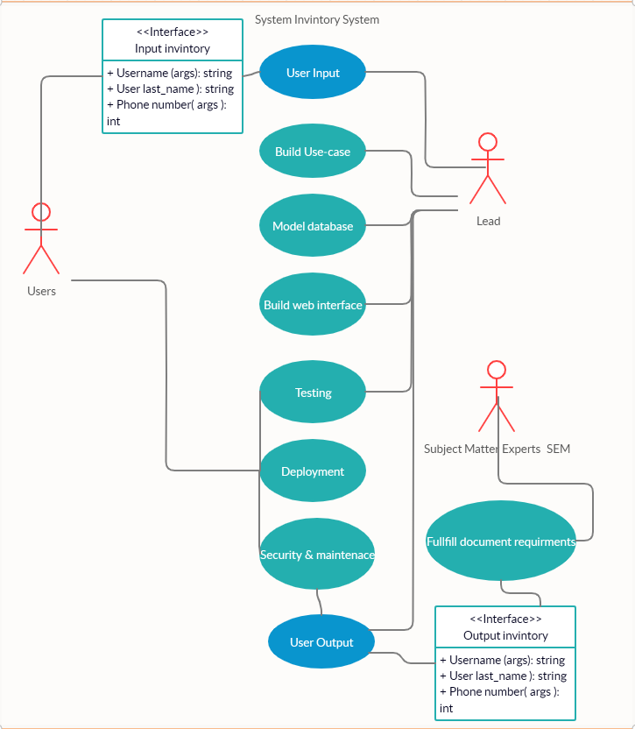

# Analysis Documentation:

**Business Rules:**

Business rule is meant to help everyone understand the logic of each area of the service or product that is being developed. These rules will apply to a CRUD based inventory system for student registration at Rasmussen College. Business rules are denoted with (**BR**-#)

**BR-1** Users will be able to access a responsive web-based interface capturing user input from 3 input field types  First_Name, Last_Name and Telephone_number to register to Rasmussen College.

**BR-2** First_Name, Last_Name and Telephone number input data will be stored in MySQL database backend hosted on an Azure server.

**BR-3** PHP scripting will implement database access, query, and logic between backend MySQL database and the user input data.

**BR-4** An HTML form input “Submit” button will be accessible below the main user input fields to capture input user data to facilitate the query of the MySQL database where user input data will be stored via the PHP logic.

**BR-5** Below the input form and “Submit” button on the user form a 4-column output table will be generated based on the PHP code logic that will access the stored data from the MySQL database; displaying the data fields plus the active MySQL database the current data is stored in for users to visualize.

**BR-6** Below the output table area of the interface there will be a red JavaScript input button called “Delete” implemented through PHP scripting that will delete the latest row from the given output table and the MySQL data base to Unregister a submitted student, omitting their name from the list.

**BR-7** Below the “Delete” button will be another script bas generated table that will show all current and active tables in the MySQL data base through logic that will read and update the actual table programmatically. Any new tables added to the database will be added to this table after page. This will occur from Update asynchronous logic that will check and update the current tables through a procedurally script set Time out function. This will facilitate the “Update proponents of the CRUD implementation.

**BR-8** Below the Active database table there will be another form button that will generate an active alert with current database input data of registered users for READ Only implementation of the CRUD app.

**BR-9** Interface will be styled with bootstrap being responsive to mobile devices and have a clean appeal to all users.

**System Requirements:**

**Functional requirements** *(denoted as* ***F****- plus number)*

1. Setup and install web app service with MySQL on Azure service.
2. Create new MySQL database tables.
3. Build reporting table and load data.
4. Create a new PHP based web page user interface.
5. Create PHP connection strings.
6. Write a PHP process database activity.
7. Write CSS syntax to format web user interface.
8. Publish PHP based web application to Azure cloud services.
9. Use developer tools to modify and fix inefficiencies with the web application.
10. Code base used for user interface will consist of HTML, CSS, JavaScript, PHP and MySQL
11. Web server will be developed as a service using Azure
12. MySQL database will be implemented and set up through Azure service.

**Behavioral requirements** *(denoted as* ***B****- plus number)*

1. Users form to register students **First_Name** input will be stored in MySQL web server database back end first table field.
2. Users form to register students **Last_Name** input will be stored in MySQL web server database back end first table field.
3. Users form to register students **Telephone_number to** input will be stored in MySQL web server database back end first table field.
4. User will press “Submit button to query database and store data input values into the MySQL database selected table.
5. After user submission is handled by the “Submit” button. the output table below the button will populate with current **active_database_table** name value and the submitted user input form values, per row.
6. User will be able to press the “Delete button will be under the output table with the ability to delete the latest submission of data in the output table and the active database table in MySQL.
7. User will be able to view the Active database Table directory below the “Delete” button to show all active tables in the current MySQL database back-end implementation.
8. User will be able to press a readme submit button to output all database values in the output table to read only an alert message as read only data.

**Requirement Priorities:**

This section will outline the business requirements as well as their importance to the project. Priority ratings should include critical, high, medium, low, and future. Begin with critical needs and work down to low and future requirements.

|  |  |  |  |
| --- | --- | --- | --- |
| Priority | Description | Rationale | Stakeholders |
| *Priority level* | *Description of the requirement* | *Why is requirement included?* | *Departments or teams impacted* |
| High | **BR-1** | Register users | IT admin |
| High | **BR-2** | Register users | IT admin |
| High | **BR-3** | Register users | IT admin |
| Med | **BR-5** | Register users | IT admin |
| Med | **BR-7** | User interface | IT admin |
| High | **F-1** | Implement input data | Developers |
| High | **F-4** | Implement input data | Developers |
| Med | **F-5** | Implement input data | Developers |
| Low | **F-7** | Database implementation | Developers |
| High | **F-8** | Frontend development | Developers |
| High | **B-1** | Inventory create data | User & Admin |
| High | **B-2** | Inventory create data | User & Admin |
| High | **B-3** | Inventory create data | User & Admin |
| Med | **B-5** | Inventory update data | User & Admin |
| Med | **B-6** | Inventory delete data | User & Admin |
| Low | **B-8** | Inventory read data | User & Admin |

# Design Documentation:

**Design Documentation:**

1. Cloud services needed for this project
2. Flow chart of the course lab application
3. Implement a historical change grid at the top of the document

**Cloud service implementation requirements:**

The system components needed for this web application are listed below denoted by (CS) for cloud services. These tools will allow for testing through setting up virtual environments, component-based testing, API testing, performance testing, user integration, authentication, mock services and user data for testing ETP, and other enterprise services to facilitate the end product.

CS-1 Azure cloud database service – for this project we will need to use integrated cloud tools for testing and distributing data for the web application.

CS-2 Azure DevTest Lab – used to provide virtual machine access for testing, managing cost, enabling self-service, automation, scaling and proof of concept need for the web application.

CS-3 Azure Files - offers fully managed file shares in the cloud that are accessible via the industry standard Server Message Block (SMB) protocol. Azure file shares can be mounted concurrently by cloud or on-premises deployments of Windows, Linux, and macOS.

CS-4 Azure Active Directory B2D - (Azure AD) enterprise identity service provides single sign-on and multi-factor authentication to create test users.

CS-5 Microsoft Graph - will allows the management of user accounts in your Azure AD B2C directory providing create, read, update, and delete methods in the Microsoft Graph API.

CS-6 Google Cloud Identity – Another authentication API to use for testing provisions of up unlimited email, groups, and user request.

CS-7 Blaze meter - provides components needed for the entire continuous testing process with mock services, performance testing, API monitoring, and functional testing

CS-8 User testing – a cloud-based test platform used to create real time feedback from real users to implement feedback data on the overall design aspects such as interfaces and functionality of the application.

[1]

**Flow chart of the course lab application:**

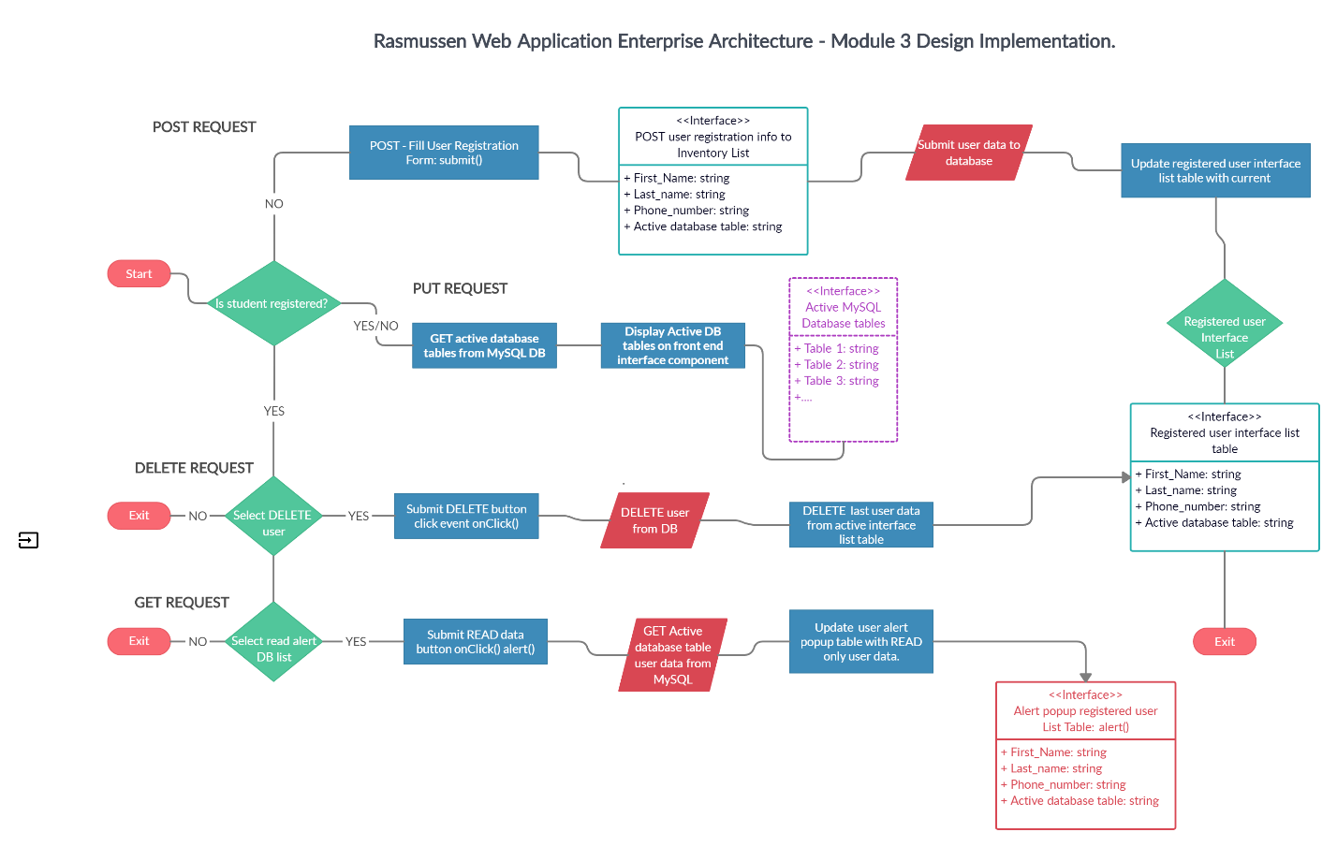

# Implementation Documentation:

**Developer testing environment requirements:**

Here are the developer design and implementation specifications for local testing environment needed for the current project. Specifications are denoted by (DT-1…)

DT-1 Initial logic test - test script procedure will need to validate through console.log frontend registration form input values are being submitted through script logic component.

DT-2 Initial design test -Browser test using dev tools to determine if user interface and data modules are responsive

DT-3 Initial logic test - the user interface registration form test will need to show connectivity to database submission posting input values to specified labeled inputs testing persistence POST functionality to the database tables being queried.

DT-4 Initial logic test - Test procedure to test persistence and DELETE data from user submissions from the backend.

DT-5 Initial logic test - Test procedure to test READ capabilities of persisted data allocated in user database and its tables.

DT-6 Initial logic test - Test procedure to test UPDATE capabilities of persisted data allocated in user database and its tables.

DT-7 Initial design test -Browser test functionality of Delete buttons to determine if user interface and data modules connecting to logic.

DT-8 Initial design test -Browser test functionality of Read buttons to determine if user interface and data modules connecting to logic. Test should include console log or alert event to display persisted user data.

DT-9 Initial design test -Browser test functionality of user data should be displayed in company modules to show list table of registered users.

DT-10 Initial design test -Browser test functionality of user data should be displayed in company modules to show active database tables.

**Developer UAT (User acceptance) requirements:**

Here are the procedures for the team developers to outline the UAT systems of the user acceptance testing environment to implement duplication of production application for user test and acceptance of the current progress and shareholder acceptance of the project. Denoted as (UAT-1).

UAT-1 Initial design user test – will be a replica of the functioning interface input form. Developer should push user interface module to get shareholder approval.

UAT-2 Initial design user test – will be a replica of the functioning interface input form plus the list data. Developer should push user interface module to get shareholder approval.

UAT-3 Initial design user test – will be a replica of the functioning interface input form plus the table references and display active database tables. Developer should push user interface module to get shareholder approval.

UAT-4 Initial design user test – will be a replica of the functioning full interface input form, list tables, and in its entirety. Developer should push full mockup of production ready user interface module to get shareholder approval.

UAT-5 Initial persistence test – display the functionality of user persistence input data should be submitted to the backend then displayed in the list table on the front end based on the full mockup of production ready user interface module to get shareholder approval.

UAT-6 Initial logic test – display the functionality of user persistence of all input data fields and all button events action to show the creation, read, update, and delete functionality of the application. This should consist of a full mockup of the production ready user full interface to get shareholder approval on workflow and usability. Testing will not include browser load time capabilities or refresh rate and optimized performance.

**Four Week project Schedule:**

This project schedule is defined for System administrator and his/her team to delegate the determine timelines, expectations, and other project details

**Week1:**

|  |  |  |  |
| --- | --- | --- | --- |
| System Task | Description of task | Timeline | Project details |
| Software application design | Develop full schema, design, and lifecycle of application | 5 days | Rasmussen inventory application Software architect |
| Services and resources | Set up all services and resources to host application | 3 days | Rasmussen inventory application Systems administrator. |
| Use-case | Design use case for project | 2 days | Rasmussen inventory application Software architect |
| Database design | Complete setup of MySQL data base with service to host application and delegated tables for user registration and backup will need to be created | 2days | Rasmussen inventory application database development |
| Form design | Complete frontend form design | 1 days | Rasmussen inventory application design |
| Form logic modules | Write logic to connect form and persist to database | 2 days | Rasmussen inventory application logic development |
| Test scripts | Build test scripts to define logic modules | 1day | Rasmussen inventory application test scripts |
| Tables design | Design tables for registered user output display | 1 day | Rasmussen inventory application frontend design |
| Module output design | Create the frontend modules to display the active user databases | 1 day | Rasmussen inventory application script logic module for output to database table |
| 1-week project overview | Ensures all task delegated to team are complete and on track and coordinates with system administrator for application requirements. | 4 days | Rasmussen inventory application project management. |

**Week2:**

|  |  |  |  |
| --- | --- | --- | --- |
| System Task | Description of task | Timeline | Project details |
| Frontend CRUD buttons | Frontend development and styling of the buttons on the front user end | 1 day | Rasmussen inventory application design |
| Module output logic | Modular scripting logic will need developed to output current register user data to the frontend interface | 1 day | Rasmussen inventory application logic development |
| Module user test | Use test scripts will need to be written for the module output logic | 1 day | Rasmussen inventory application logic development |
| Tables logic | Modular scripting logic will need developed to output current active database tables to frontend interface | 2 day | Rasmussen inventory application logic development |
| 2-week project overview | Ensures all task delegated to team are complete and on track | 4 days | Rasmussen inventory application project management. |

**Week3:**

|  |  |  |  |
| --- | --- | --- | --- |
| System Task | Description of task | Timeline | Project details |
| Read alert | Develop alert function to capture and READ data from the database | 1 day | Rasmussen inventory application logic development |
| Update module | Create update module logic to update current user with PUT | 1 day | Rasmussen inventory application logic database development |
| Delete module | Create DELETE functionality module to delete registered user from the data base. | 2 day | Rasmussen inventory application logic database development |
| Delete testing | Test script for test bench to validate persistence and delete of registered user. | 1 day | Rasmussen inventory application logic database development |
| Testing database | Full testing data base will need to be duplicated for UAT with clear copy of all functional tables | 2 days | Rasmussen inventory application logic database development |
| 3-week project overview | Ensures all task delegated to team are complete and on track | 4 days | Rasmussen inventory application project management. |
| Insights | Ensure all team members are in compliance and overview current status of project with software architect | 3 days | Rasmussen inventory application Software architect |

**Week4:**

|  |  |  |  |
| --- | --- | --- | --- |
| System Task | Description of task | Timeline | Project details |
| final frontend task | Frontend developers will need to meet with project manager review final notes and make sure all design guidelines are met | 1 day | Rasmussen inventory application frontend development & design |
| Final testing logic | Database developers will run test scripts to ensure database is being persisted properly and efficiently. | 1 day | Rasmussen inventory application logic database development |
| Database replication test | Systems administrator will need to verify the database has been copied and ready for UAT testing | 2 day | Rasmussen inventory application System Administrator |
| Full application bed test | Developers will need to review all project manager and WBS task to allocate final completion on the project. | 1 day | Rasmussen inventory application developers |
| Submit & review for production release | Submit to project manager and scrum final notes before application is deployed | 3 days | Rasmussen inventory application System Administrator, project manager, and Software architect |

**WBS (Work break down structure):**

This WBS will outline the deliverables for the current project and break down the task need to complete the project and designated timeframes and cost for each delegated task. Please see the table below

|  |  |  |
| --- | --- | --- |
| **Task Name** | **Duration** | **Assigned** |
| Develop application lifecycle and design. | 5 days | Software architect |
| Develop Use case and PM documentation. | 2 days | Software architect |
| Set up resources and services to host application. | 5 days | Systems administrator |
| Design the Form UI. | 4 days | Frontend developer |
| Build UI for output registered users. | 2 days | Frontend developer |
| Build UI modules to display active databases. | 3 days | Frontend developer |
| Build UI to handle CRUD capabilities. | 3 days | Frontend developer |
| Ensure deign is on schedule. | 2 days | Project manager |
| Develop and Design database for application and set up DB resources. | 6 days | Database developer |
| Implement logic to submit user inputs from UI. | 5 days | Backend developer |
| Implement logic to read back submitted users to a list table on the UI. | 4 days | Backend developer |
| Implement logic to persist and update user data from the UI. | 3 days | Backend developer |
| Ensure project is on track and UAT test have been developed. | 2 days | Systems administrator |
| Implement modular logic to GET active database tables. | 3 days | Backend developer |
| Develop UI alert pop up and logic to display READ data to user of registered and deleted users. | 4 days | Frontend developer |
| Add active databased new user submit is stored in in output UI list. | 5 days | Database developer |
| Ensures all task delegated to team are complete and on track. | 6 days | Project Manager |
| Collaborate with developers to go over flaws and over new findings or abilities in the software. | 5 days | Software architect |
| Ensure database has been replicated for UAT testing. | 4 days | Systems administrator |
| Ensure application meets full CRUD specifications of the user . | 2 days | Backend developer |
| Ensure test bed is set up. | 4 days | Backend developer |
| Ensure all workbench test have been completed. | 3 days | Project Manager |
| Ensure UAT is ready for user to demonstrate. | 4 days | Systems administrator |
| Ensure all task have been complete for application deployment. | 6 days | Project Manager |
| Complete final analysis on application based on team data. | 4 days | Software architect |
| UAT testing Final | 1 day | User |

**Project users and roles**

Here we will define the specific roles and purpose being performed on this current project user roles for specific variation and responsibilities of implementation for the current project. This will describe their roles and provide details about what they will contribute to the project.

|  |  |  |
| --- | --- | --- |
| Role | Description | Project Phase week |
| System administrator | Is responsible for the upkeep, configuration, and reliable operation of computer systems in which the application will be implemented on including its databases and resources. | 1,2,3,4 |
| Software architect | Is the lead software developer expert who makes high-level design choices and tries to enforce technical standards, including software coding standards, tools, and platforms. | 1,2,4 |
| Front end developer | Is the developer responsible for the interface and other applicable design elements of the application that users engage with. | 1,2,3,4 |
| Backend developer | Is responsible for server-side web application logic and integration of the work front-end developers do. They will implement web services and APIs used by front-end developers and develop the logic to connect to the database. | 1,2,3,4 |
| Project manager | Will be in charge of planning and leading software project. | 1,2,3,4 |
| Database Developer | Database developers ensure that database management systems (DBMS) can handle massive quantities of data and are responsible for integrating the frontend logic and maintaining logic to the database tables. | 1,2,3,4 |
| User | User is the shareholder and or the originator of the application, or other users who will test and approve each phase through the UAT of the application. The user interacts with the application and uses it. | 1,3 |

# Maintenance Documentation

**Scope Creep:**

The scope is the extent of what the project will produce the main I did and implementation of the application. Scope creep is the adding of additional features or functions of a new product, requirements, or work that is not authorized or that come along after development has begun. By working on unapproved features of a product, a project team devotes time to the unauthorized changes.

The work to incorporate these changes must usually be done within the original time and budget estimates, leaving less time for approved parts of the scope. These tangents in application development could actually cause hold ups in production, systems, resources, and time of original agreed upon features. Exceeding agreed upon deadlines can put projects over budget. Added resources being implemented will cost developers, project management, system admins, and other team members more time on the project . Not to mention all the systems resources being overused such as database, storage, CPU processioning, bandwidth, programming, and such will be added.

In essence scope creep is like adding more water to bucket that is already full of water. When someone turns on the hose it is going to overflow and make a big mess of the entire application. from a project manager standpoint introducing new element into a system application can expend the work they have to do trying to juggle resources to make it work out correctly. This can cause serious issues with productivity and usability and possible scalability.

Scope creep creates pitfalls usually preceding factors such as unrefined scope definition, inconsistent process for collection product requirements, undefined project lengths lack of formal scope or requirement management, lack of sponsorship and stakeholder involvement.

**Here is a list of possible solutions to avoid Scope creep:**

* Project managers can create tight scope statements, with features in and out of scope
* Business analysts can create scope models to align project team's mental models
* develop a change management process in the scope management plan and follow them both
* Use tools like RACI chart matrix to get commitment for approvals and for providing input, review, testing, etc.
* Keep projects as short as possible and focused.
* Decompose projects into smaller sub projects
* Have developers track system progress and schedules for protect mangers to review and see if teams are going off track

**Metric Baselines:**

The goal behind using baseline metrics and measurement in software engineering is to identify and control what can affect software development and the project as a whole.

A **software metric** stands for a potential area where measurement can be effectively applied to a certain software module or its specifications. In other words, a metric assumes taking some data from the application development lifecycle and using it for measuring software developer productivity.

**Software productivity** can be defined as the ratio between the functional values of software produced to the efforts and expense required for development (AltexSoft, 2017).

**Metrics should be consistent, available, auditable, and repeatable. The goal is to use metrics to collect requirements for:**

1. Project cost
2. Process effectiveness
3. Improvements
4. Developers performance

The summation of these factors is what determine productivity. Productivity metrics for software development will identify the factors determine the effectiveness of the team, new insights that can improve existing product life cycles, locate bottlenecks, and help take action to deploy better code, faster, at a lesser cost.

**There are 4 main metric types:**

* **Product metrics** − Describes the characteristics of the product such as size, complexity, design features, performance, and quality level.
* **Process metrics** − These characteristics can be used to improve the development and maintenance activities of the software.
* **Project metrics** − This metrics describe the project characteristics and execution. Examples include the life cycle of the software, cost, schedule, and productivity.
* **Software quality metrics** –(Subset)Focus on the quality aspects of the product, process, and project metrics.

The software quality model defines 6 important indicators of software quality We will use these models to associate the baseline metrics with these categories. Within each main category there will be specific **performance metrics** to gauge and determine baseline metrics for overall productivity(Info Pulse, 2018)(Tutorialspoint, 2020).

**Software quality model indicators:**

* Reliability
* Maintainability
* Testability
* Security
* Performance efficiency
* Rate of delivery
* Usability

**Software quality indicators**

|  |  |
| --- | --- |
| **Reliability** | Number of failures (per calendar time) |
| **Maintainability** | Lines of code |
| **Testability** | # of technologies & resources used to test |
| **Security** | Time to fix failures, number of errors |
| **Performance efficiency** | Load Testing, stress testing, response time |
| **Rate of delivery** | Number of stories |
| **Usability** | Completion rate, satisfaction level |

# Software Development Productivity Baseline Metrics Chart

|  |  |  |  |  |  |  |  |
| --- | --- | --- | --- | --- | --- | --- | --- |
| Metric Indicator | Test metric | Purpose | Unit | Wk1 | Wk2 | Wk3 | Wk4 |
| Maintainability | CPU utilization | Utilization of CPU cloud resources | *CPU %* | *1.116* | *4.5* | *0.833* | *2.40* |
| Maintainability | Lines of code | Completed lines of code | *Per week* | *46* | *105* | *185* | *237* |
| Maintainability | RAM utilization | Utilization of RAM cloud resources | *RAM %* | *44* | *51* | *53* | *58* |
| Maintainability | Data Persistence | Data in persistent to cloud storage | *Data In kb* | *407.1* | *6.2* | *25* | *6* |
| Rate of delivery | Lead Time | Time between the definition of a new feature and its availability to the user | *Hours (calendar time)* | *8* | *11.3* | *6* | *14* |
| Testability | Bug rates | Average number of bugs that are generated as new features are being deployed per feature and test. | *int* | *2* | *6* | *4* | *3* |
| Rate of delivery | Throughput | The total value-added work output by the team in units of work(UOF) Per assignment | *UOF* | *4* | *4* | *4* | *4* |
| Reliability | Cycle Time | Total time from start to finish of code. | *Days,*  *(calendar time)* | *3* | *2* | *1* | *4* |
| Security | Cancelled defects | Time to fix errors and failures. | *Hours*  *(calendar time)* | *3* | *1.5* | *6.3* | *4* |
| Performance efficiency | Render Speed | Load times of frontend after data submission. Using Google page speed | *per 0.0000 sec* | *1.8* | *1.2* | *4.2* | *2.7* |
| Maintainability | Garbage Collection | Amount of resources pooled by computer storage that is being used by a program code release. | *Per kb* | *256* | *816* | *325* | *425* |
| Maintainability | Errors in code | Amount of errors found in code per unit. | *Per error int* | *4* | *6* | *5* | *12* |

**Purpose of a project kickoff meeting:**

**The purpose of a project kickoff meeting is to introduce the team(beginning and end of project), to understand the project background, understand what objective and outcome of the project will look like, understand what needs to be done, who will be doing it, and agree on how to work together effectively. it is a chance to level and get the entire development team on the same page.**

**In order to have a successful project kickoff meeting there are many factors that need to be handled as described below.**

* **For a successful project kickoff meeting it could be a good idea to have an internal kickoff or briefing with the team before seeing the client or shareholders. This could get everybody on the same page and answer questions that could take up valuable time. An informed team and a proper plan help you get the most out of your discussion with the client and the stakeholders.**
* **A clear agenda should be set for the project meeting itself that allows time to meet the following objectives.**
* **An executive summary should be developed and presented. It is essential that the project is defined after the formal introduction of the team. This will define the project expectations right from the start. Being prepared is the best-case scenario for leaving a good first impression.**
* **The kickoff meeting should define the who, what, when, where, and why of the project, the big picture of should be presented.**
* **Scopes and deliverable should then be discussed to set the foundation for the project. This is where project guidelines on all levels are clearly defined, expectations are clarified, project goals are met, and any details will be covered. This is also where the boundaries of the project should be defined as well to prevent scope creep.**
* **Then the responsibility and roles should be presented to identify each group, team or individual who will be working or monitoring the project. This identifies the chain of command of the project. All team members should give feedback or brief description of their responsibilities at each project phase. If everyone understands what’s expected of them, they will not have to spend so much time after the fact answering unnecessary emails or wasting valuable time.**
* **Timeline schedules should be over viewed. As well as any possible milestones that conform to the project budget and available resources. These should be discussed briefly their probability to communicate high level implications of the project. This is to say deadlines for critical assignments should be discussed here yet.**
* **Before bringing the meeting to a close stakeholder’s should be given some details on the communication channels, meeting schedules and project management technology you’ll be using to manage the project. Be sure to provide any links, phone numbers or other details the project team will need in order to participate in meetings or access project information.**

# Change Request Documentation

**Change Request:**

|  |  |
| --- | --- |
| **Author:** | Shaun Pritchard |
| **Requestor:** | Software Engineering |
| **Date:** | Monday, August 10, 2020 |
| **Change ID:** | *(to be assigned by the project manager)* |
|  |  |
| **Requested Change:** | *Describe the change being requested:*  This request is built out new software implementation modules to handle user input validation and user security measures for the inventory application. |
| **Impact/Risks:** | ***Describe the impact/risk to the business or project if the change is not undertaken:***  Without this build the environment will be vulnerable to exploitation risking shareholder data integrity. Causing breaches and loss of valuable resources  ***Describe the impact/risk to the project if the change is approved:***  This can lead to system crashes, malicious database manipulation, and even database corruption. |

|  |  |
| --- | --- |
| **Impact Analysis** | |
| **Schedule:** | ***What additional time is needed to complete this change?***  10 days  ***When will resources need to be available to work on this change (include IT and Business resources)?***  Upon completion of bench testing and mock UAT testing as soon as 3 days |
| **Resources:** | ***Who will develop and test this change?***  Software engineering in coordination with database Engineering and system IT will develop the change. Frontend development team will complete the preliminary test to hand off to Project manager for UAT.  *Lead database and software engineering will need to:*  Database engineers will need to duplicate database for testing write specific SQL queries and schema. Software engineering will utilize schema to develop the scripting modules, security code, and logic that will connect to the front-end developers input elements to omit the change. |
| **Environment:** | *What environments will be impacted? (e.g., applications, desktop environment, servers, etc.)*  Application and server environments. |
| **Budget:** | *What change in the budget is required to accept this change?*  The project manager has figured an additional $26,598.00 will be needed to for the time and resources to complete this change on a bottom budget. |

**Change Request Procedure:**

The chart below will map out the change procedures need to implement this change request. These are technical details given by the requestor.

|  |  |  |  |  |
| --- | --- | --- | --- | --- |
| **Dept** | **Procedure Task Description** | **Decision** | **Reason for Rejection** | **Date** |
| Database Engineer | Build use case diagram of validation inputs | 🞏Approved 🞏Rejected |  |  |
| Database Engineer | Replicate test database | 🞏Approved 🞏Rejected |  |  |
| Database Engineer | Design process charts and schema outline | 🞏Approved 🞏Rejected |  |  |
| IT & Software Architect | Develop production methods for security measures to stop Input attacks. buffer overflows, automated input, data validation API, DoS | 🞏Approved 🞏Rejected |  |  |
| Software Engineer | API and webhook modules | 🞏Approved 🞏Rejected |  |  |
| Software Engineer | Logic implementation of JWT and proper database scripting logic | 🞏Approved 🞏Rejected |  |  |
| Frontend Developer | Implement source code version control | 🞏Approved 🞏Rejected |  |  |
| Software Developer | Write validation scripting logic | 🞏Approved 🞏Rejected |  |  |
| Database Developer | Write query validation logic | 🞏Approved 🞏Rejected |  |  |
| Software Developer | Write test logic scripting functional modules | 🞏Approved 🞏Rejected |  |  |
| Frontend Tester | Frontend test validation with mock user input | 🞏Approved 🞏Rejected |  |  |
| System admin | Kick off to wrap up project details | 🞏Approved 🞏Rejected |  |  |
| User | UAT testing | 🞏Approved 🞏Rejected |  |  |
| PM, Software Architect | Sign off on code, versions, and Updates | 🞏Approved 🞏Rejected |  |  |

**Signature page:**

*All projects lead approvers must validate change to scope and implementation from their signature below.*

|  |  |
| --- | --- |
| **Software Architect** |  |
| **Approval:** | _______________________________________  **Print Name**  ________________________________________ **Date:**__________________ |
|  | **Signature** |
|  |  |
| **IT Administrator**  **Approval:** | ________________________________________  **Print Name**  ________________________________________ **Date:**__________________ |
|  | **Signature** |

|  |  |
| --- | --- |
| **Project Management**  **Approval:** | ________________________________________  **Print Name**  ________________________________________ **Date:**__________________ |
|  | **Signature** |

**Solution**

|  |  |
| --- | --- |
| **Solution Description:** | *Describe the solution that resolves the underlying problem.*  **This change will validate user input and implement security measures and best practices for allocation of user data while offering a secure experience for the user.** |
| **Date Completed:** | *When was the solution deployed?*  **Tuesday August 11, 2020** |

**Approval or Rejection**

Use the chart below to document approval or rejection of completed change.

|  |  |  |  |
| --- | --- | --- | --- |
| Name and Title of Approver | Decision | Reason for Rejection | Date |
| **Alan Dennis, Senior Software Architect** | 🞏Approved 🞏Rejected |  |  |
|  | 🞏Approved 🞏Rejected |  |  |
|  | 🞏Approved 🞏Rejected |  |  |
|  | 🞏Approved 🞏Rejected |  |  |
|  | 🞏Approved 🞏Rejected |  |  |

Next Steps

This section outlines the next steps that will be taken if approval is received and/or if there is a rejection and additional work needs to be completed. If you want the approver to provide you with more information regarding additional changes to be made, include instructions here.

Document Tracking

|  |  |  |
| --- | --- | --- |
| **Date** | **Action Taken** | **By Whom** |
| Monday, August 10, 2020 | Complete Mod 6 change request procedures | Shaun Pritchard |

# References

AltexSoft. (2017, 11 3). *How to Measure Software Quality*. Retrieved from https://www.altexsoft.com: https://www.altexsoft.com/blog/engineering/what-software-quality-really-is-and-the-metrics-you-can-use-to-measure-it/

Azure Active Directory B2C. (2020). *Azure Active Directory B2C*. Retrieved from https://azure.microsoft.com/en-us/services/active-directory/external-identities/b2c/: https://azure.microsoft.com/en-us/services/active-directory/external-identities/b2c/

Azure NetApp Files. (2020). *Enterprise File Storage, Powered by NetApp*. Retrieved from https://cloud.netapp.com/azure-netapp-files?: https://cloud.netapp.com/azure-netapp-files?

Blaze Meter. (2020). *Mock Services*. Retrieved from https://guide.blazemeter.com/hc/en-us: https://guide.blazemeter.com/hc/en-us

Google Cloud . (2020). *Federating Google Cloud with Azure Active Directory: Configuring provisioning and single sign-on*. Retrieved from https://cloud.google.com/: https://cloud.google.com/architecture/identity/federating-gcp-with-azure-ad-configuring-provisioning-and-single-sign-on

Info Pulse. (2018, 10 19). *TOP 10 SOFTWARE DEVELOPMENT METRICS TO MEASURE PRODUCTIVITY*. Retrieved from https://www.infopulse.com: https://www.infopulse.com/blog/top-10-software-development-metrics-to-measure-productivity/

Microsoft Azure. (2020). *Azure Active Directory*. Retrieved from https://azure.microsoft.com/: https://azure.microsoft.com/en-us/services/active-directory/?&ef_id=Cj0KCQjw6uT4BRD5ARIsADwJQ1_3NPNOA0tOwSD00HuMrKxSownRFv8rXZ8l9Fuz63o2W5010yxBR50aAvMkEALw_wcB:G:s&OCID=AID2100131_SEM_Cj0KCQjw6uT4BRD5ARIsADwJQ1_3NPNOA0tOwSD00HuMrKxSownRFv8rXZ8l9Fuz63o2W5

Microsoft DevTest Labs. (2020). *DevTest Labs*. Retrieved from https://azure.microsoft.com/en-us/services/devtest-lab/: https://azure.microsoft.com/en-us/services/devtest-lab/

Tutorialspoint. (2020). *Software Quality Metrics*. Retrieved from https://www.tutorialspoint.com: https://www.tutorialspoint.com/software_quality_management/software_quality_management_metrics.htm

User Testing. (2020). *Real-time feedback.* Retrieved from https://www.usertesting.com/: https://www.usertesting.com/

Modern Analyst.(2020).Business rules Retrieved from.

<https://www.modernanalyst.com/Resources/Articles/tabid/115/ID/1442/Use-Cases-and-Business-Rules-Can-They-Work-Together.aspx>

References

1

1. (Microsoft Azure, 2020) (Microsoft DevTest Labs, 2020) (Azure NetApp Files, 2020) (Azure Active Directory B2C, 2020) (Google Cloud , 2020) (Blaze Meter, 2020) (User Testing, 2020)